**\*\*\*Other Events at the Arts Center to bring in a crowd**: **8 am** 5K Reindeer Run/Walk, **8:45 am** 1-Mile Run/Walk, **9 am** Kids Fun Run**, and** 9 am to 3 pm - 4th-12th Grade Art Exhibit, Gingerbread Exhibit/Contest and Everyone is invited to make FREE Christmas. Ornaments.

**VENDOR NAME: ______________________________________________________________________**

**E-MAIL ADDRESS: _____________________________________________ TELE #: ___________________**

**TYPE OF ITEMS TO SELL: __________________________________________________________________**

**ALL VENDORS WILL BE PROVIDED AN 8 FT. TABLE AND 2 CHAIRS. WE WILL HAVE ROOM FOR 30 VENDORS AT THE ANNA ART CENTER. FIRST COME, FIRST SERVE. I WILL NOT SAVE SPACES. THIS IS A “NO HOLD” EVENT. THERE IS A DEADLINE ON THIS FORM, NOVEMBER 11, 2022.**

**THE ARTS CENTER WILL BE OPEN ON FRIDAY FROM 4-6 PM for EARLY SET UP AND 7 AM FOR SETUP.**

**ELECTRICITY NEEDED? YES OR NO (LIMITED OUTLETS, CAN’T GUARANTEE)**

**COST OF 8 FT. TABLE SPACE IS $20.00 + $20 security deposit that will be returned to you at 3 PM. YOU MUST STAY WITHIN THE SPACE YOU PURCHASE. YOU CAN PUT ITEMS BEHIND YOUR TABLE IF THERE IS ROOM BUT NOT IN FRONT OR TO THE SIDE WHERE IT WILL BLOCK ANOTHER VENDOR.**

**# OF SPACES NEEDED ________________ CHECK # __________________ FOR $ _______________**

**MAKE CHECKS PAYABLE TO: ANNA ARTS CENTER, 125 West Davie Street, ANNA< IL 62906**

**CHECKS MUST BE RECEIVED NO LATER THAN NOVEMBER 11, 2022. NO SPOTS WILL BE RESERVED WITHOUT PAYMENT. NO REFUNDS UNLESS WE HAVE A STANDBY LIST AND THE SPACE CAN BE FILLED.**

**CONCESSION STAND OPEN: BBQ Sandwiches, chips/drink $5 or Hot Dog/Chips/Drink $4 PLUS other goodies.**

**ADVERTISING ON SOCIAL MEDIA, TELLING FRIENDS AND FAMILY, OR EVEN PRINTING OUT THE FLYER AND DISTRIBUTING THEM ARE APPRECIATED. YOU DO NEED TO POST THE EVENT ON FACEBOOK AND INVITE YOUR FRIENDS AND FAMILY. WE WILL ADVERTISE IN THE LOCAL NEWSPAPER, POST FLYERS, ETC.**

**REMEMBER, THE MORE PEOPLE, THE GREATER THE OUTCOME.**

**ANY QUESTIONS PLEASE CONTACT Lee’s cell 904-625-1109 or email vabchlee@gmail.com**

**Downtown Anna Christmas**

**Holiday Bazaar at the Anna Arts Center**

**November 26, 2022, 9 am to 3 pm**

**Rent a Space TODAY!**

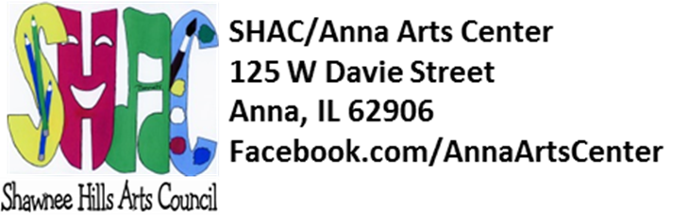

**Share the Table!**