Larry Braun’s Photography Exhibit at the Anna Arts Center
The exhibit will occur July 19, 2022 through August 11, 2022 at the Anna Arts center, 117 West Davie Street, Anna, Illinois. There will be an Opening Reception on July 19, 2022, Tuesday, from 6 to 8 p.m. Everyone is invited - The reception is FREE and refreshments will be served.
Larry is a prolific photographer who is a landscape and streetscape photographer living in Benton, Missouri. The focus of his work is outdoors in small towns, state parks, and historic districts of Illinois, Missouri, Arkansas and Kentucky.
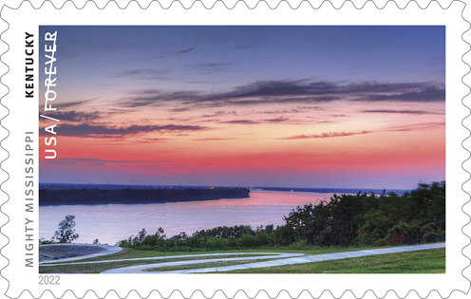
Larry’s most notable photo to date is one he took of the Mississippi River that was selected to be used on a USPS forever stamp. This stamp is included in the “Mighty Mississippi” 2022 stamp portfolio. The portfolio is made up of 10 photographic stamps, each representing a state found along the river course. His photo of the river is used to represent the state of Kentucky since it was taken from a bluff in Wickliffe, KY.
the river course. His photo of the river is used to represent the state of Kentucky since it was taken from a bluff in Wickliffe, KY.
Photography has been his lifelong interest, although he did take time off to raise his family and pursue a career in chemistry. His art has been in multiple exhibitions, including Margaret Harwell Art Museum in Poplar Bluff, Missouri, the transition space of the Crisp Museum, the Southeast Missouri Art Council, and the Sikeston Depot Museum. Larry’s art work has also been featured in Rural Missouri (Feb 2022), the Southeast Missourian, Missouri Life, and the magazine, The Best Years. His photographs have been used on book covers, phonebook covers and online magazines.
Larry shared, “Using my own digital work flow, I often add a texture to my photographic images. For me this creates a unique artistic interpretation of my subject, which some describe as adding a 'painterly feel' to the images.”
The exhibit will be open to view on Thursdays from 5 to 7 p.m., Fridays from 11 a.m. to 2 p.m., and Saturdays and Sunday from 1 to 3 p.m. It is free to visit the exhibit and everyone is encouraged to come see Larry’s work. If you have a group that wants to see Larry’s art please call Lee’s cell 904-625-1109 or email vabchlee@gmail.com.
You can check out some of his photography at http://www.larrybraunphotography.com/ .
Picture next page with possible caption
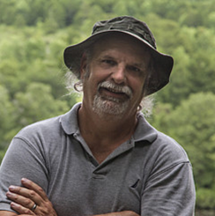
Possible caption: Please join us for an Opening Reception for Larry Braun’s Photography Exhibit on July 19, Tuesday, from 6 to 8 p.m. at the Anna Arts Center, 117 West Davie Street, Anna, Illinois. Everyone is invited - The reception is FREE and refreshments will be served. The exhibit will occur July 19 through August 11, 2022 at the Anna Arts center. The exhibit will be open to view on Thursdays from 6 to 8 p.m., Fridays from 11 a.m. to 2 p.m., and Saturdays and Sunday from 1 to 3 p.m. It is free to visit the exhibit and everyone is encouraged to come see Larry’s work. If you have a group that wants to see Larry’s art please call Lee’s cell 904-625-1109 or email vabchlee@gmail.com.

